Thank you for buying the **Easy Performant Outline**, we hope it will help you in your project.

If you liked our product, do not forget to rate it in an Asset store: <http://u3d.as/1EXT>

Your feedback will help me improve the project.

If you have any suggestions or questions, you can write to this email: [*pirate.parrot.software@gmail.com*](mailto:pirate.parrot.software@gmail.com)

*\*New information is marked in blue*

**Demo video:** [**https://youtu.be/83UbDFeVe2I**](https://youtu.be/83UbDFeVe2I)

**Setup video:** [**https://youtu.be/JV2KAGBMLKA**](https://youtu.be/JV2KAGBMLKA)

**Easy Performant Outline 2.0 Setup**

**URP Setup**

In order to set up the urp support, please click **Tools** → **Easy performant outline** → **Setup** menu item:  
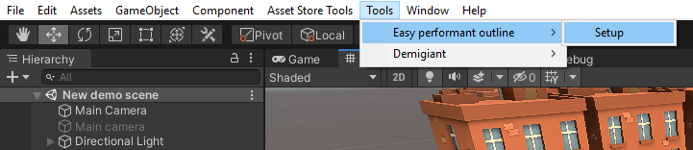

After follow the steps proposed by the wizard:

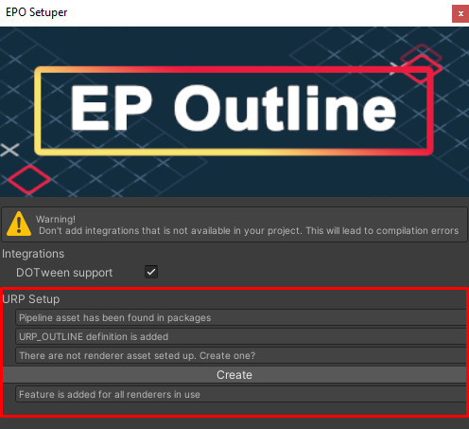

**DOTween Setup**

You can enable **DOTween support** in the same window under **Integrations** (*please enable it only if you have DOTween added to your project*):

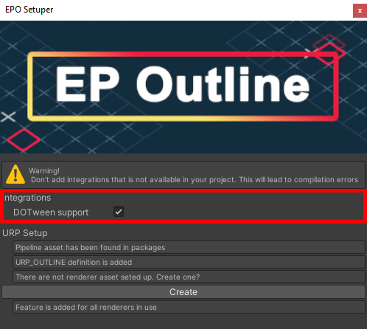

**Easy Performant Outline 2.0**

**Easy performant outline** – is asset that provides high quality outlining for Unity. It supports various outline modes and features.

**Components**

1. The *Outlinable* component is the component which indicates the objects which should be outlined by the outline system.

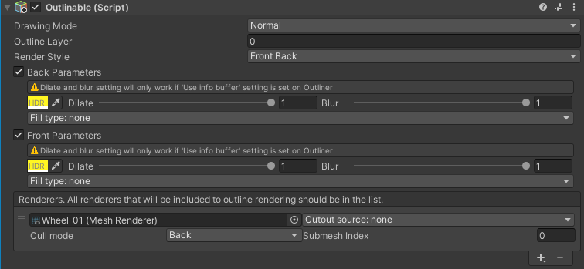

1. The *Outliner* component is describing the cameras which should render outline and the outline settings used while rendering the outline.

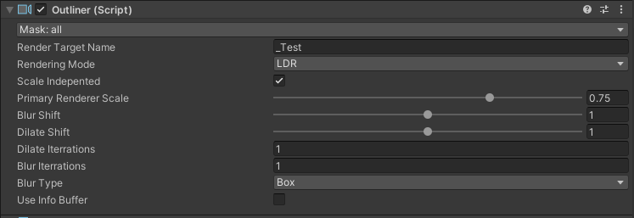

1. *The Custom target blitter* is the component which blits the texture to the screen. Most of the time should be used to blit custom render targets to the screen.

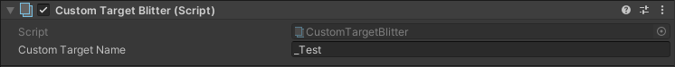

**Parameters of Outlinable**

* **Drawing mode**

*Normal* drawing mode is rendering the outline as usual. *Z only* mode is for writing to z buffer the objects that are usualy not writing to it (Like for instance sprites) in order to support overlaping sprites (See 2D demo scene). Please note that *Z only* mode is not rendering outline at all. It’s just for writing depth info.

* **Render style**

In case of *Single* mode you’ll get the best outline performance but the outline will be rendered through everything. In case of *Front back* mode you’ll get the most flexible style with back/front outline settings etc.

* **Outline layer**

The layer of the outline. In case if you should have a separate outline which can overlap you can select different layer for the outlinables and add several Outliners (More on that later). In this case the outlines will not interfear with each other.

* **Back parameters**

The parameters which will apply to the outline when it is obstructed by somethins (Let’s say behind the wall).

* **Front parameters**

The parameters which will apply to the outline which is directly visible (Not obstructed by anything).

* **Outline parameters**

Is applied to the outline if *Render style* is set to *Normal*.

**Parameters details (Shared, front and back):**

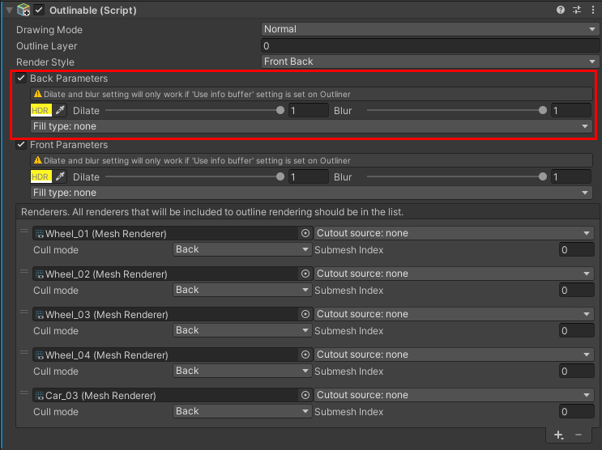

*Lets have a look at back parameters (The front works the same).*

First is the color of the outline. It will change the outline color. On the right hand side you’ll see dilate slider. If your outliner using info buffer (More on that later) you’ll be able to change per object dilate shift. To the right of that you’ll find a blur slider which is in case of using info buffer (More on that later) will change the amount of blur applied to each object.

Lower you’ll find Fill type selector. It’s a selector of the fill types available at the moment. Each of them might have different properties and describes how the fill should be rendered for each outlinable. If none is selected no fill will be applied.

* **Renderers**

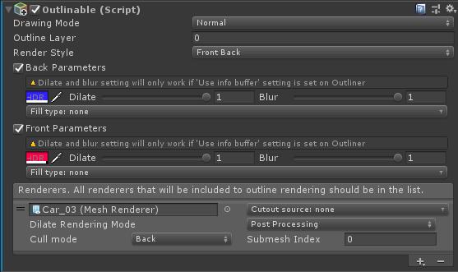

*The list which describes which targets should be rendered to produce outline.*

First parameter is the renderer which will be rendered in order to produce outline. Most of the time it should be all of the renderers included in your model/object. The disabled ones will not be rendered.

Cutout source is the parameter describing which one of the textures the system should set as a cutout alpha source. In case if something is selecter there also will be Cutout threshould slider which is describing of how much alpha should the texture have in order to not be discarded.

Dilate rendering mode is the parameter which describes what type of the dilate rendering the system should apply. Postprocessing – is the most universal and good looking option but requires more processing power. Edge shift requires you to disable **Optimize mesh data** option under **Player settings** → **Other settings** → **Optimize mesh data** and will not work on dynamicaly created meshes as weel as on statics or meshes that the plugin has no access to (Default cubes/spheres etc). If it doesn’t work correctly please try to use **Tools** → **Easy performant outline** → **Check models**. If the mode is selected you’ll see the different editor for that:

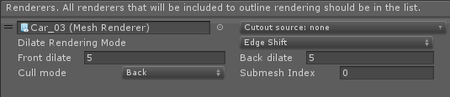

You can specify back/front dilate shifts per object.

Cull mode is the settings which is describing which cull mode should be used to render the outlinable target. Most of the time *Back* is the proper choise. In case of some geometry visible from both sides you should select *Off*. The *Front* setting should be used for extreme situations and is not commonly used but still exist.

Submesh index is the index of the submesh which will be rendered to the screen. Most of the time it will be 0, but for meshes with several submeshes you should set proper indecies to the field.

**Parameters of Outliner**

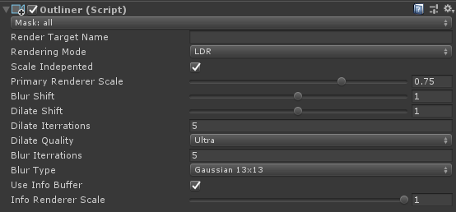

* **Mask** – which layers should the outline render. If you selected some layers on the outlinables you can discard it from rendering by this exact outlier (Althrough you can add several of them to the same camera with a different layers).
* **Render target name** – most of the time should be left empty. If you write some name in the field the outline will be rendered to the texture with the name which can be used in some custom postprocessing or *Custom target blitter* (More on that later).
* **Rendering mode** – should outliner use HDR or LDR for the outline (In case of postprocessing like bloom it’s important to use HDR in other casese it’s a waiste of resources). Please note that HDR will not be used if the camera itself is not allowed to use HDR or the system is not supporting HDR.
* **Scale independent** – if set to true will try keep the same size inf you change Pimary renderer scale property. If set to false will increase the Blur/Dilate size if making primary renderer scale smaller (Might be intendent behaviour).
* **Primary renderer scale** – if the screen resolution is lets say 800:600 than in case of primary renderer scale is set to 0.5 will render outline in 400:300 resolution. It’s important to set the setting as low as possible while keeping intendent look of the outline.  
  The lower the value the better performance you gonna get.
* **Blur shift** – how much blur should affect the final image. In case of values larger than 1 might produce artifacts.
* **Dilate sift** – how much dilate should affect the final image. In case of values larger than 1 might produce artifacts.
* **Dilate quality** – Dilate quality is defining the way dilate will be rendered. The most optimized option is base but it might have some artifacts especialy on lareger scale outline. The High and Ultra options are better in the quality level but requires a lot more computations so it’s not recommended to use it on mobiles etc.
* **Dilate iterations** – how many dilate effect iterations should be applied. The smaller the value the better performance you’ll get. The larger the value the stronger dilate effect you’ll get.
* **Blur iterations** – how many blur effect iterations should be applied. The smaller the value the better performance you’ll get. The larger the value the stronger blur effect you’ll get.
* **Blur type** – determines which of the blur types to apply. The most performant is BoxBlur, the most beautiful is Gaussian13x13.
* **Use info buffer** – if set to true will use the info buffer to determine per object blur/dilate shifts. If not the settings will not be applied but the rendering itself will be faster.
* **Info buffer scale** – how should info buffer will be scaled down. 1.0 – the same side as the primary buffer. 0.1 – 1/10th of the primary buffer size. The smaller the value the better performance you’ll get.

**Parameters of** **Custom Target Blitter**

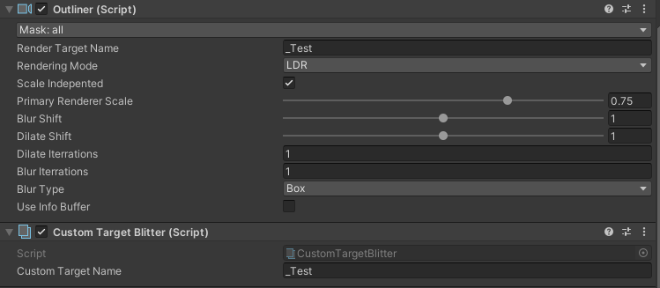

* **Custom target name** – the texture name which should be blitted to the screen.

Thank you for buying the **Easy Performant Outline**, we hope it will help you in your project.

If you liked our product, do not forget to rate it in an Asset store: <http://u3d.as/1EXT>

Your feedback will help me improve the project.

If you have any suggestions or questions, you can write to this email: [*pirate.parrot.software@gmail.com*](mailto:pirate.parrot.software@gmail.com)